Work from Home Week 4 – Year 5
Monday

Maths – Complete one challenge per day. Different sheets depending on your table group in maths.
Times table rock stars – 15 mins
Reading – 30 minutes at least per day.
When you finish a book – write a book review.

Tuesday

Maths – Complete one challenge per day. Different sheets depending on your table group in maths
Times table rock stars – 15 mins
Reading – 30 minutes at least per day.
When you finish a book – write a book review.

Geography
Task 1
Use this website to find the correct countries in Europe.
https://online.seterra.com/en/vgp/3007
Try to do this test daily to see how much your score improves!
Task 2
https://www.bbc.co.uk/bitesize/clips/zkw6sbk
Watch the following video and answer these questions:
- Where is the River Clyde?
- How long is the River Clyde?
- What is the source of a river?
- What river feature is seen in the River Clyde?
- Can you find another river in UK which has a waterfall?

Wednesday

Maths – Complete one challenge per day. Different sheets depending on your table group in maths
Times table rock stars – 15 mins

Reading – 30 minutes at least per day.
When you finish a book – write a book review.

Thursday

Maths – Complete one challenge per day. Different sheets depending on your table group in maths
Times table rock stars – 15 mins
Reading – 30 minutes per day. When you finish a book – write a review.
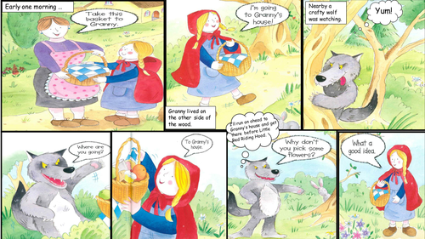
Art
Watch the following videos on Youtube https://www.youtube.com/user/tgif38/videos
Do you think you should draw any of these?
Do you think you could make a comic strip with your illustrations? With direct speech and captions to explain what is happening.
Here is an example of a comic strip:

Friday

Maths – Complete one challenge per day. Different sheets depending on your table group in maths
Times table rock stars – 15 mins
Reading – 30 minutes at least per day.
When you finish a book – write a book review.

