This week Christian’s will be celebrating Easter. Follow the link to find out more. <https://www.bbc.co.uk/cbeebies/watch/lets-celebrate-easter>

Can you name these Easter objects?

Can you remember when the lamb came to visit at Nursery? Talk to your family about the lamb. Where are lambs born and what do they eat?

This week we are learning about Lambs! Can you complete these activities at home?

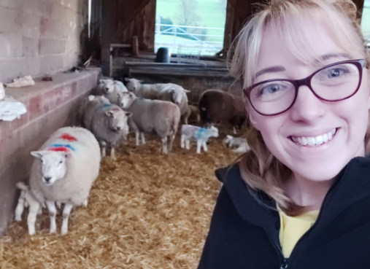

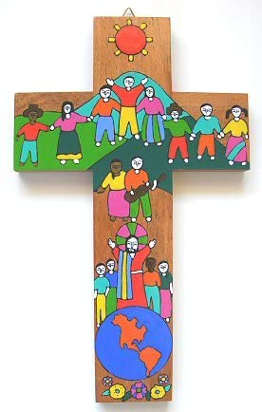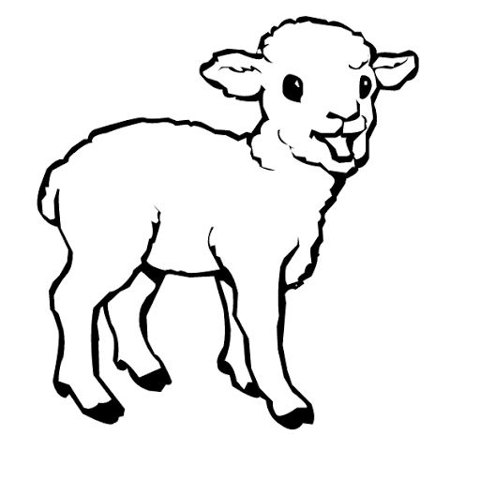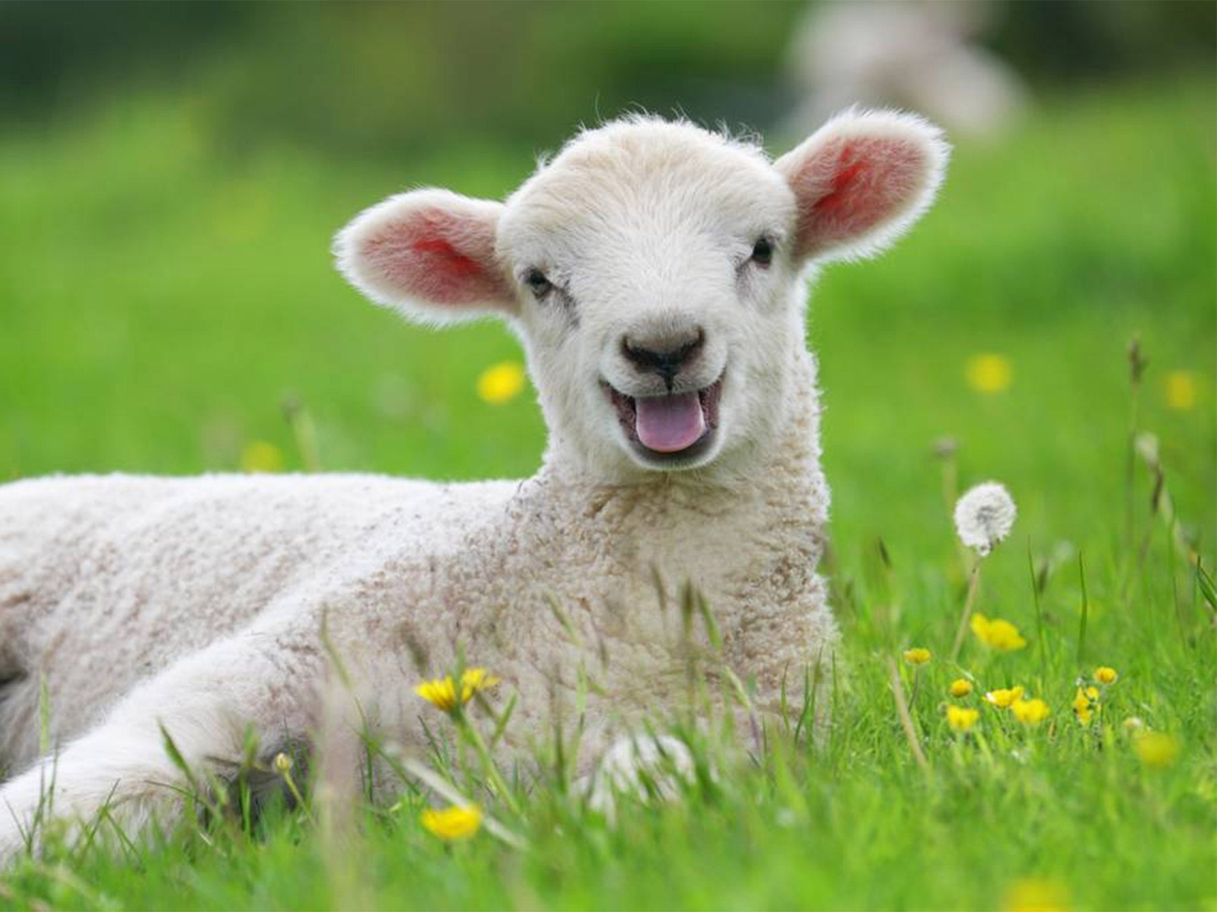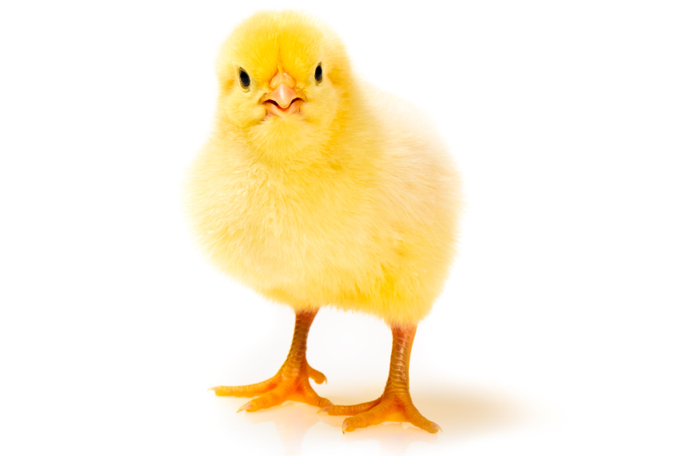

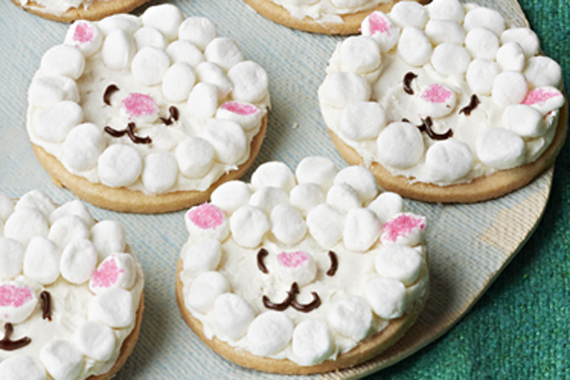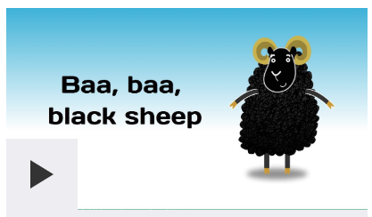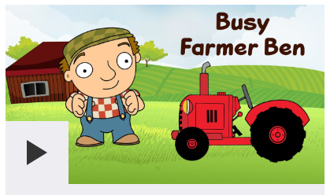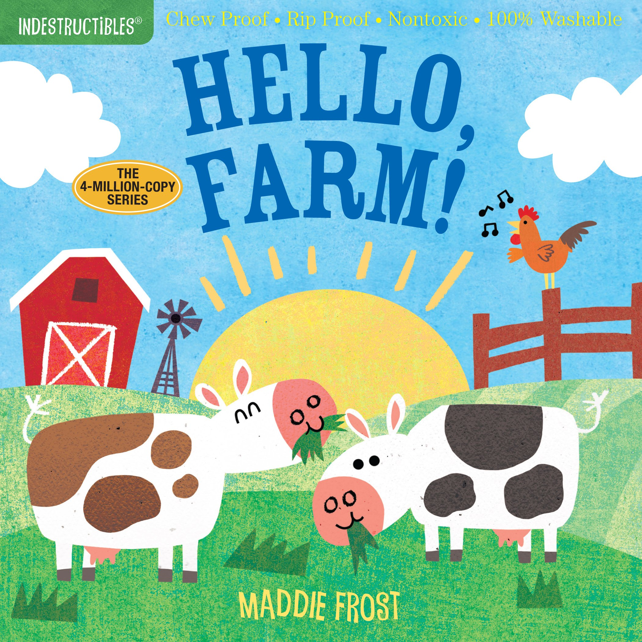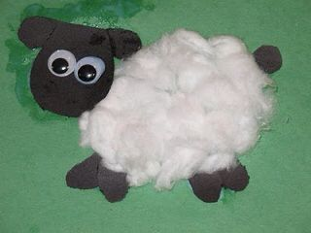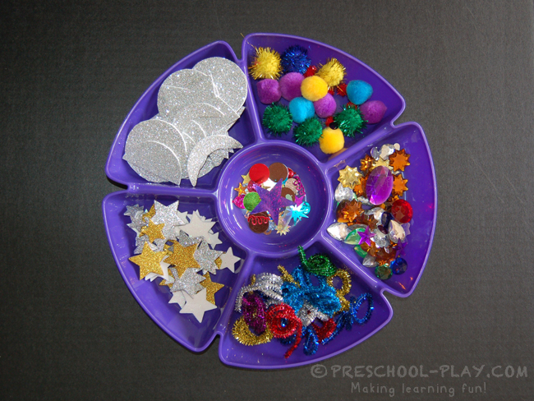

Can you use glue and collage materials to decorate a picture of a lamb?

**Nursery**

**Home Learning**

**Week 3**

Follow instructions to decorate a biscuit as a sheep! Use icing and marshmallows!

Use this website to learn these Nursery Rhymes: <https://www.bbc.co.uk/teach/school-radio/nursery-rhymes-a-to-z-index/z4ddgwx>

Can look at farm themed books with your family?