This week Christians will be celebrating Easter. Follow the links to learn more about Easter. <https://www.bbc.co.uk/cbeebies/watch/lets-celebrate-easter>

Can you remember when the lamb came to visit at Nursery? Talk to your family about the lamb. Where are lambs born and what do they eat?

This week we are learning about Lambs! Can you complete these activities at home?

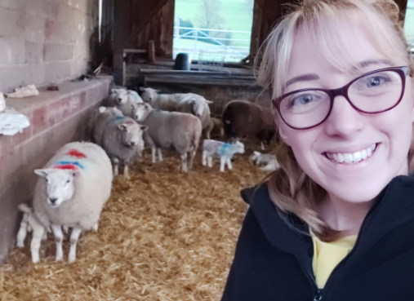

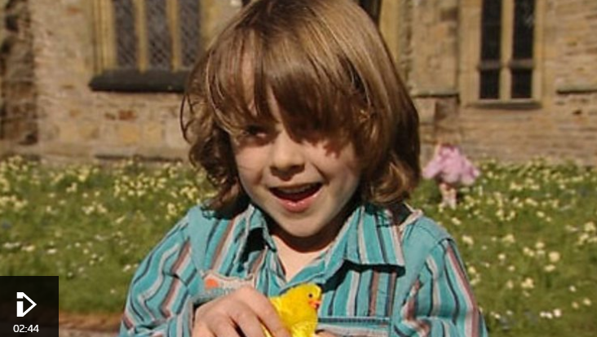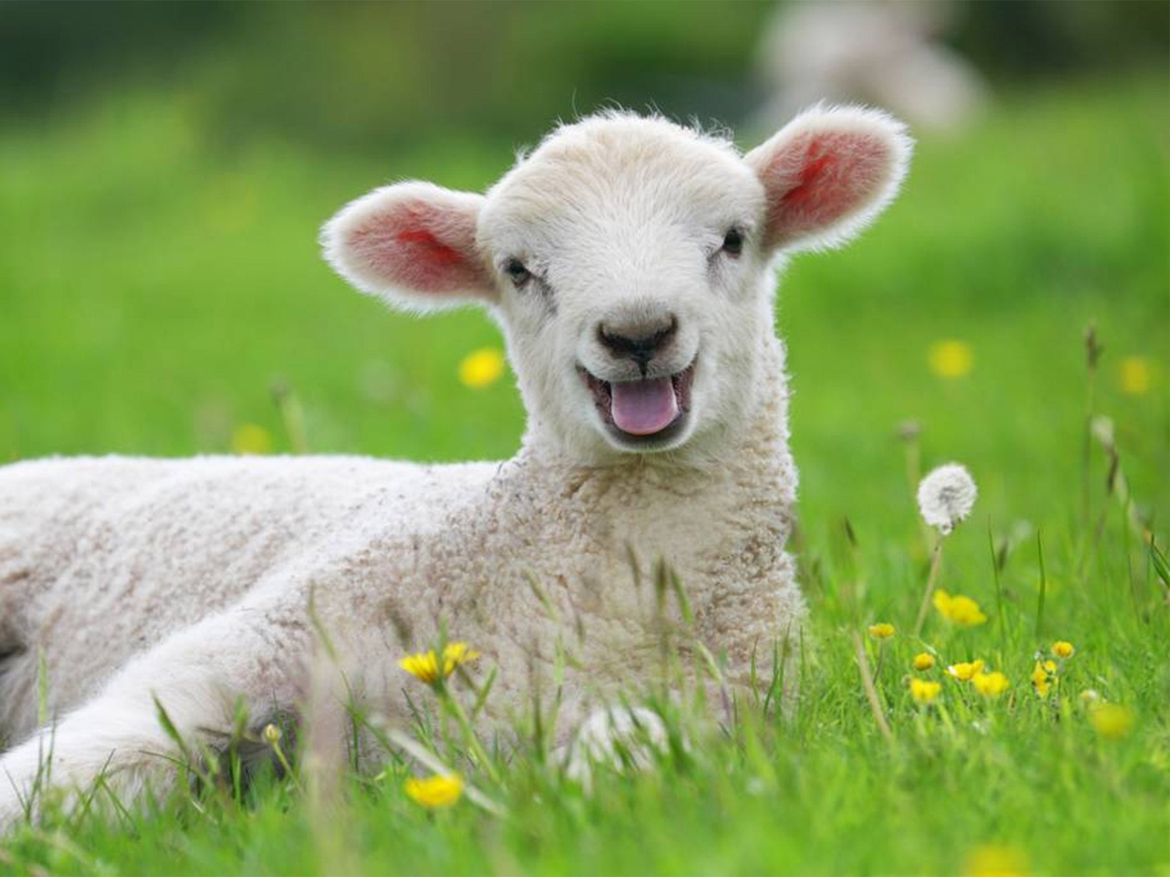

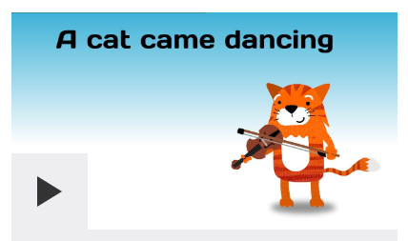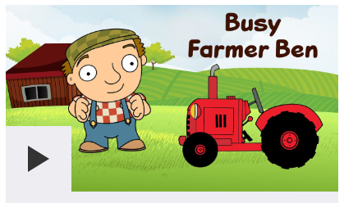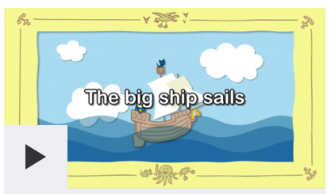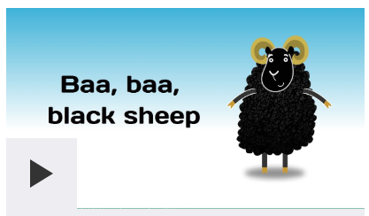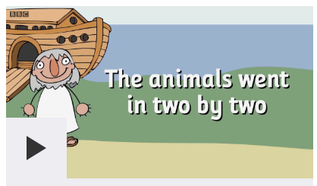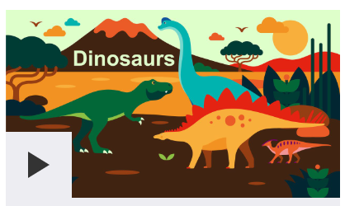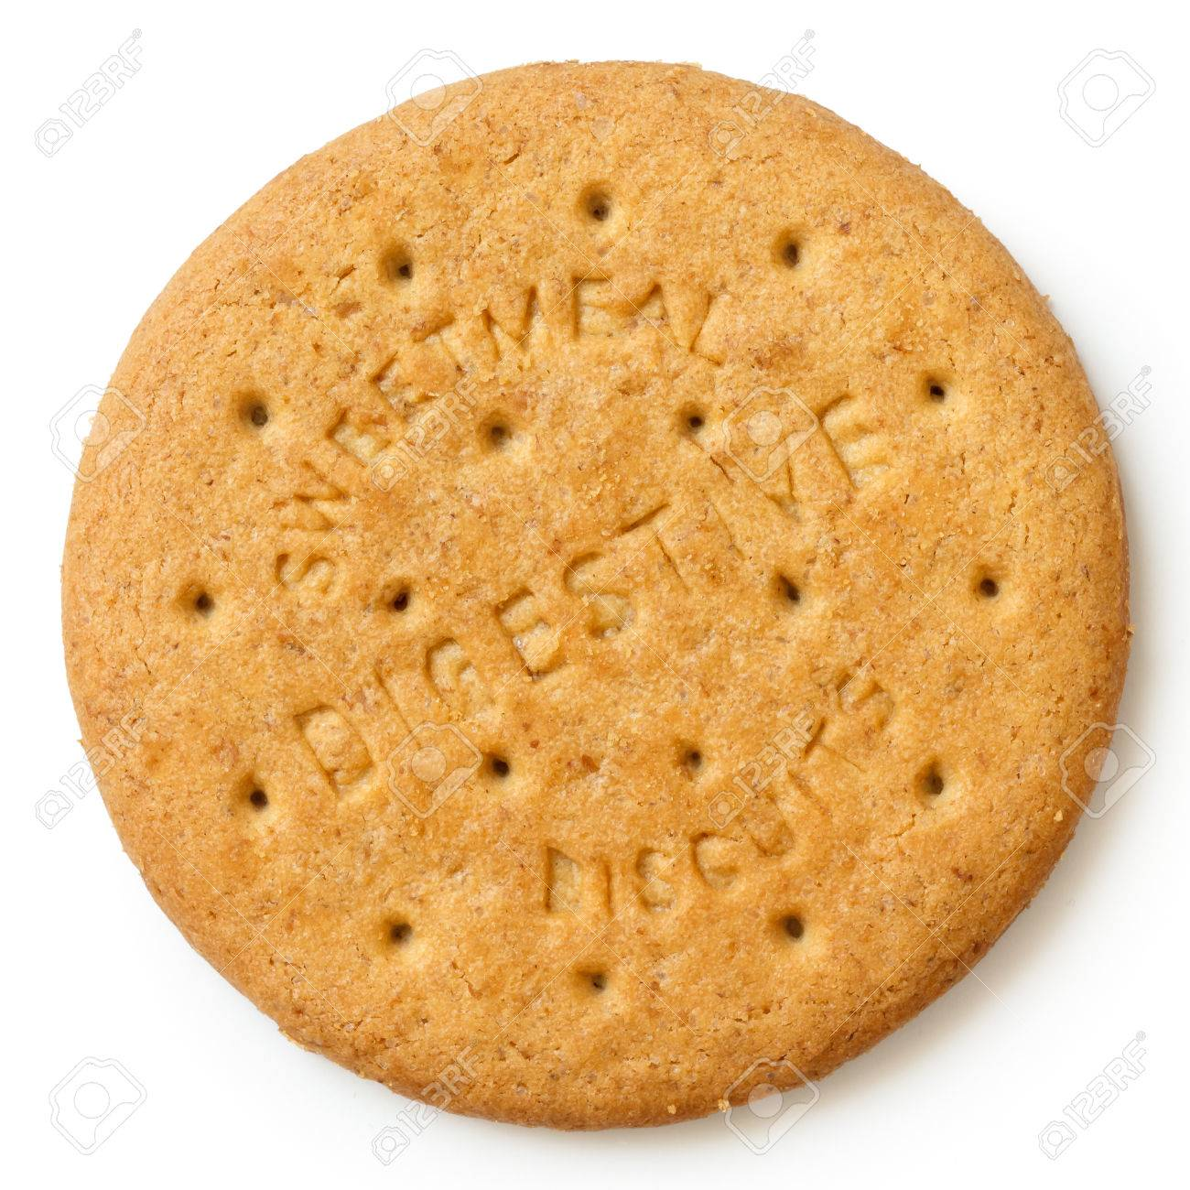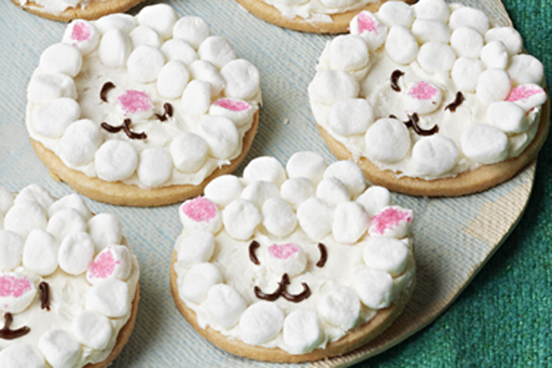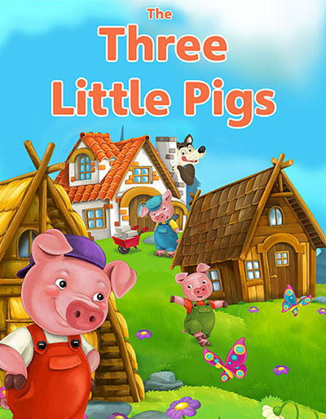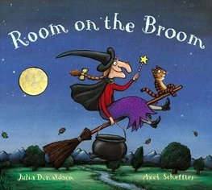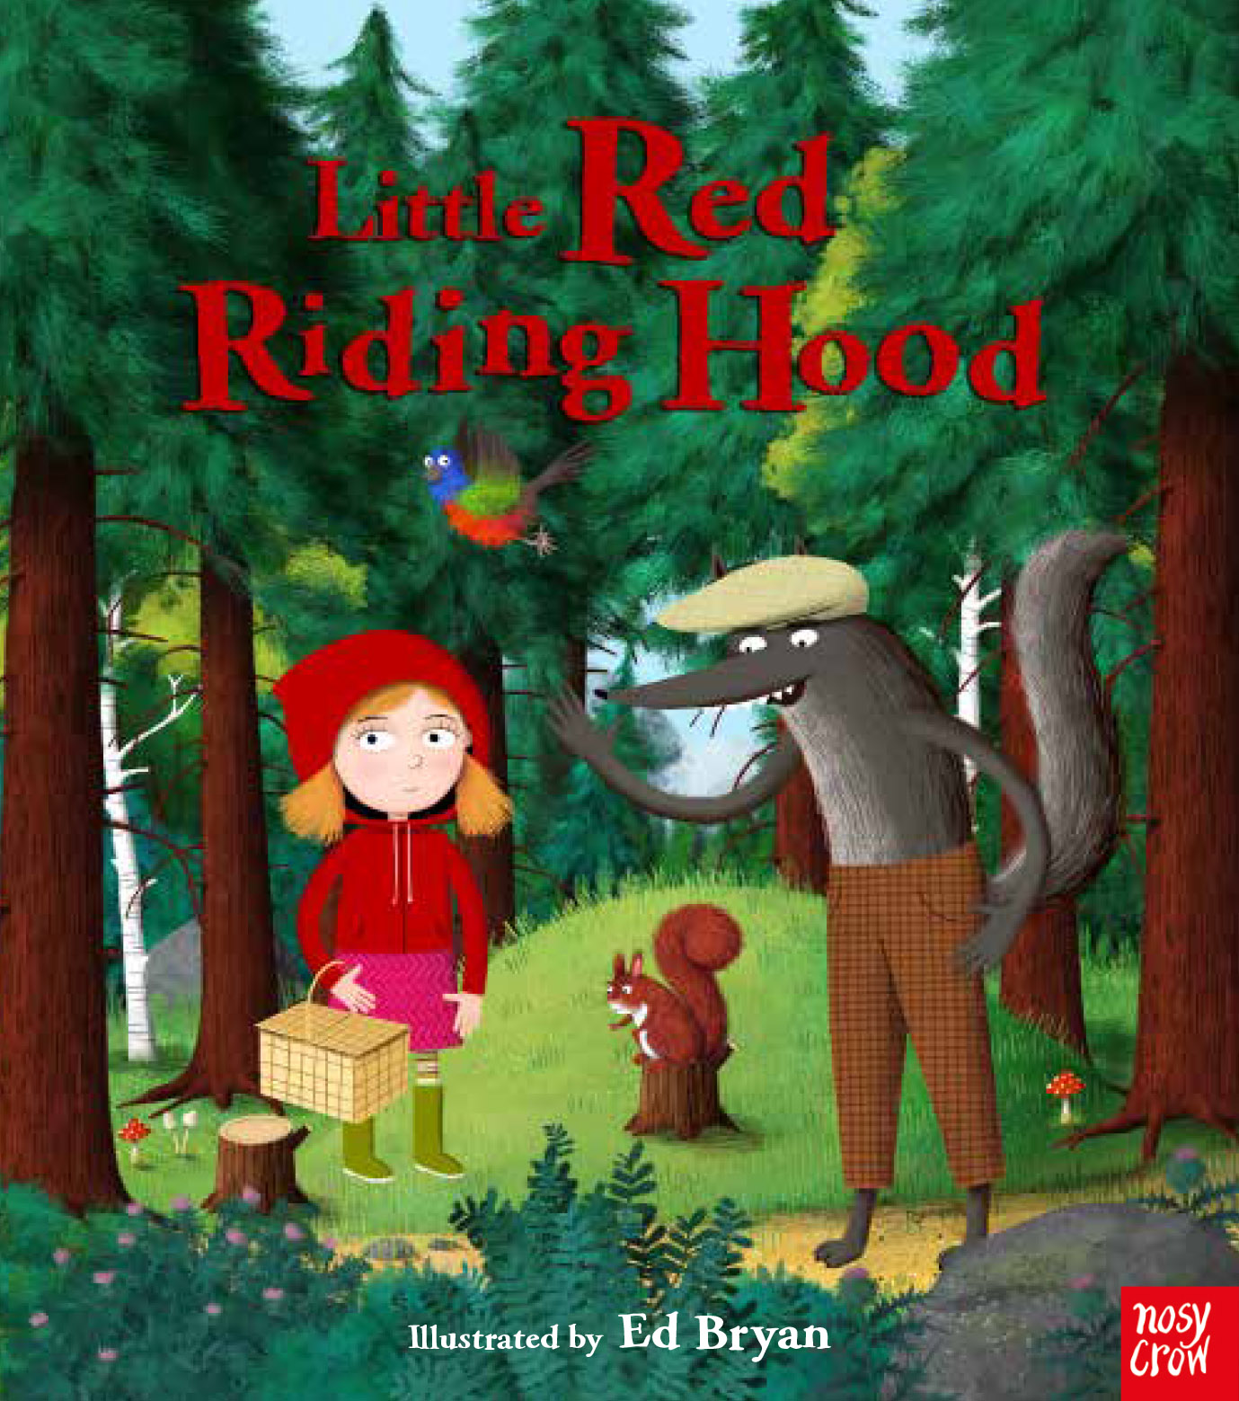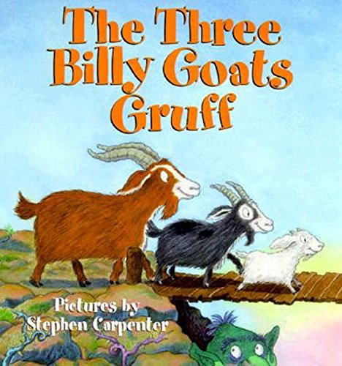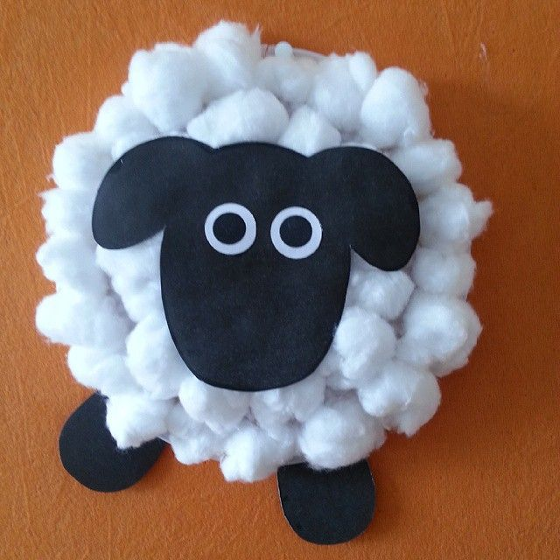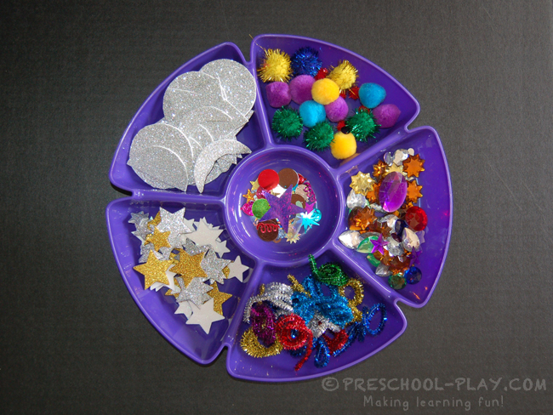

Read these stories with your family.

Can you use glue and collage materials to create a picture of a Lamb?

**Pre School**

**Home Learning**

**Week 3**

Follow instructions to decorate a biscuit as a sheep! Use icing and marshmallows!

Use this website to learn these Nursery Rhymes: <https://www.bbc.co.uk/teach/school-radio/nursery-rhymes-a-to-z-index/z4ddgwx>