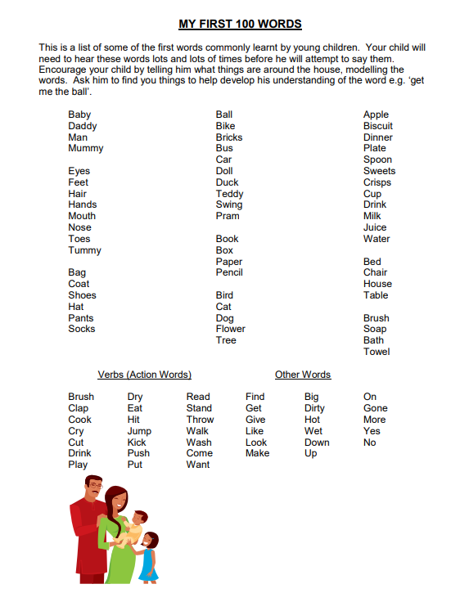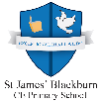

**My First 100 Words**

Support your child in learning to use these 100 words. Start with teaching your child to say the word and then teach your child to say the word in a sentence.