Wednesday 9th September 2020
Dear Parent/carer
Entry and exit for EYC children
Thank you for your patience since we returned to school. The senior leadership team met today to review the procedures we have in place and have decided to make some changes to entry and exit times for EYC children. We hope that this will make the drop-off and collection of children both safer and easier.
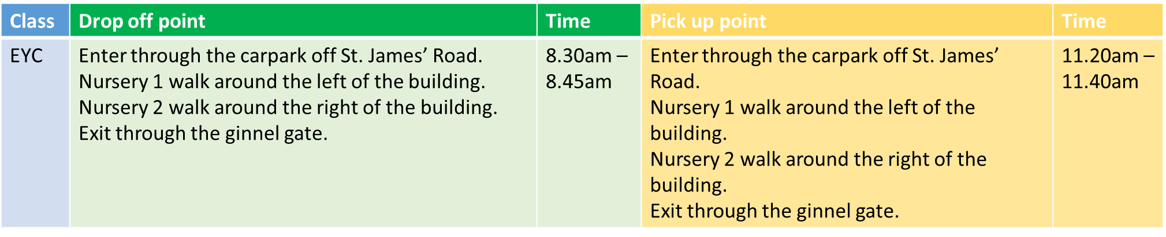
For general information
- Please remember that only people living in the same household can pick up and drop off children.
- Please remember to socially distance from people in other households.
- Please consider where you park your car if you are unable to walk to school, so as not to endanger life and be respectful to our neighbours.
- Please do not send in your child if they are feeling unwell and ring school absence line immediately to report their absence.

We appreciate that the current Covid-19 restrictions do cause inconvenience and difficulties for all of us but please be assured that we are trying our very best to minimise the impact and provide the best environment for your child.

Yours sincerely

Mr P Morgan
Headteacher

