Follow the link to learn about the Christian celebration of Easter. Can you name these Easter themed items? <https://www.bbc.co.uk/cbeebies/watch/lets-celebrate-easter>

Can you hunt for Eggs around your home or garden? How many have you found? Can you say the colour of each egg?

This week we are learning about Easter. Can you complete the Easter activities at home?

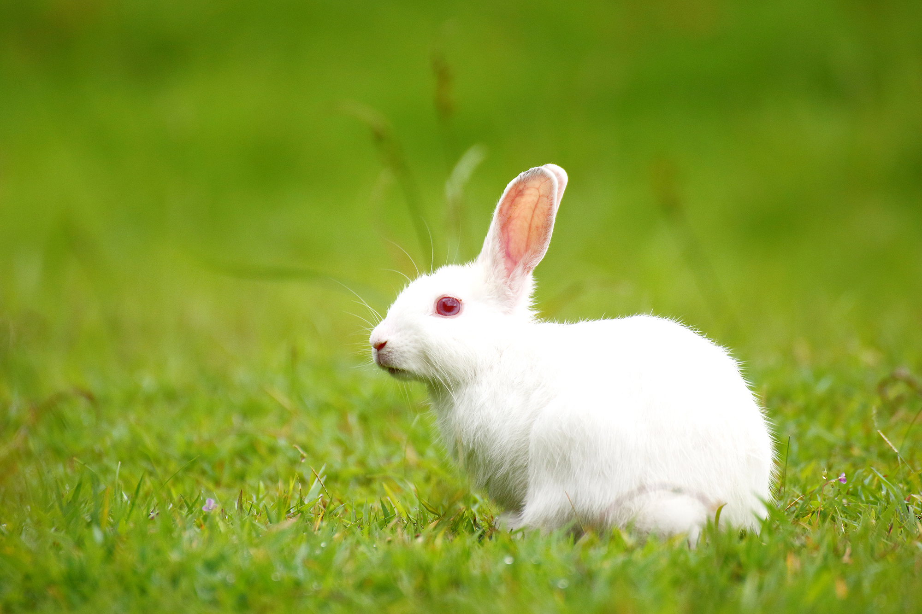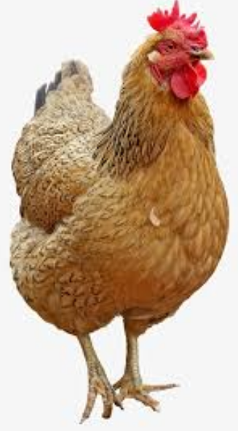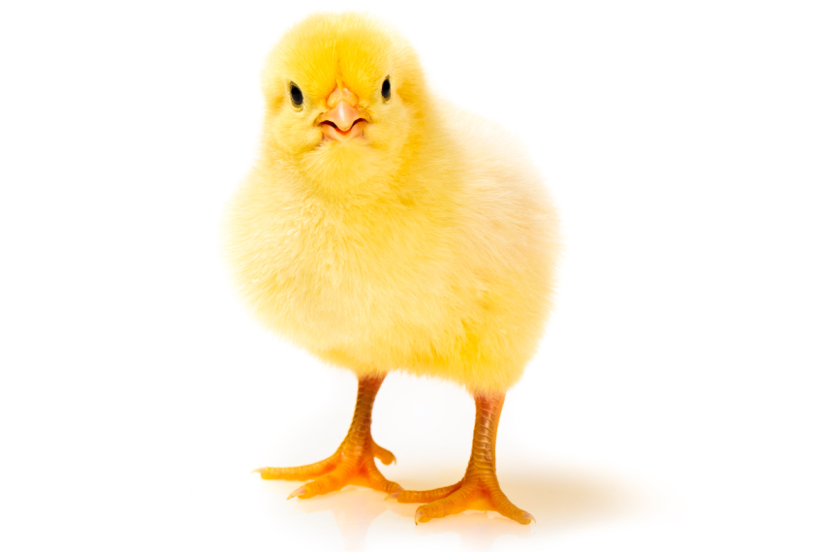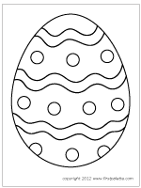

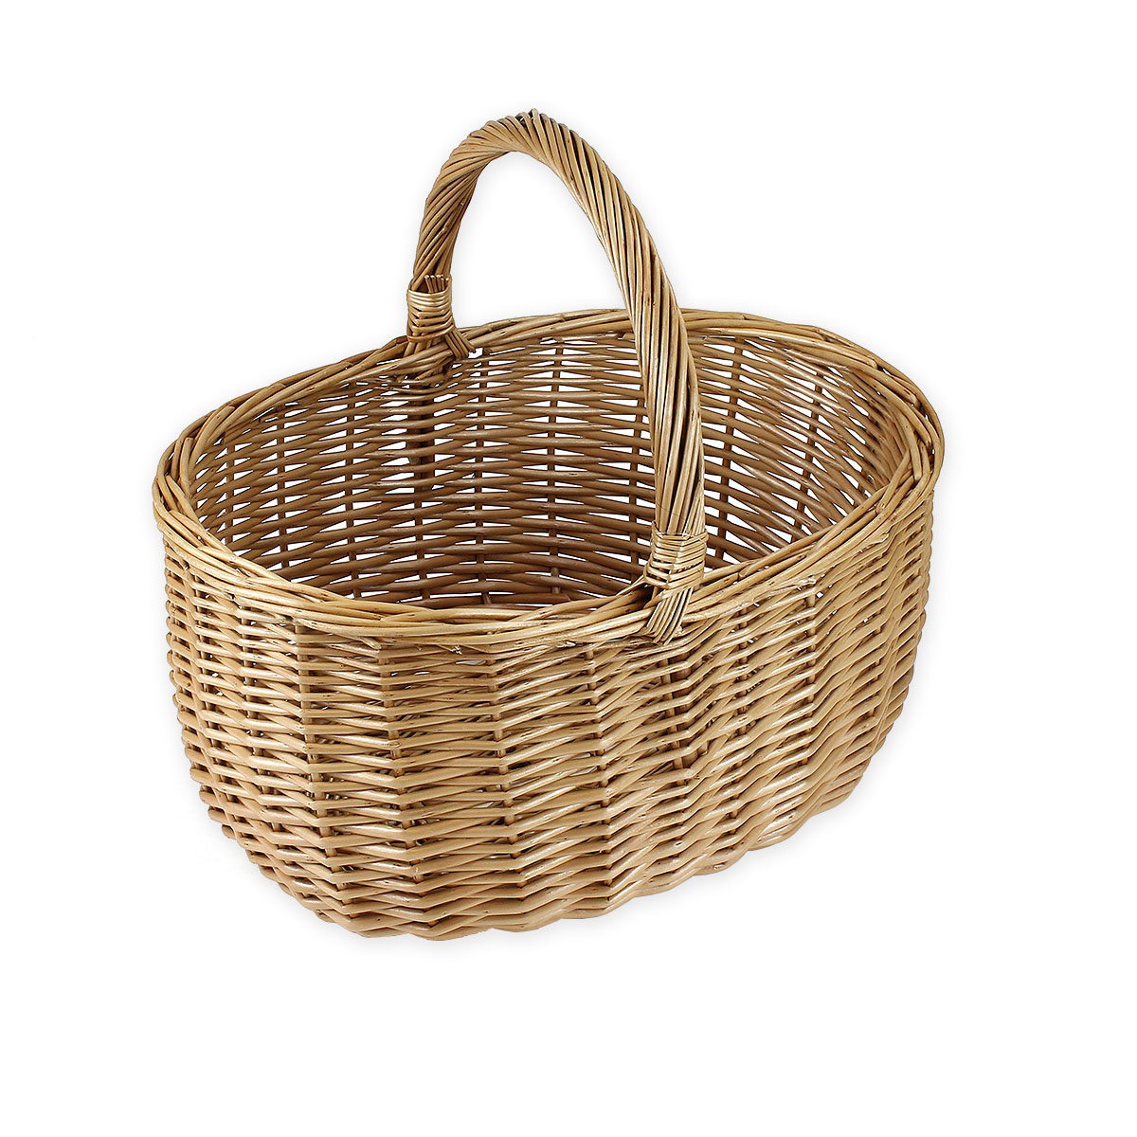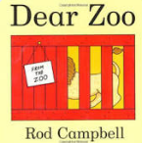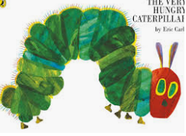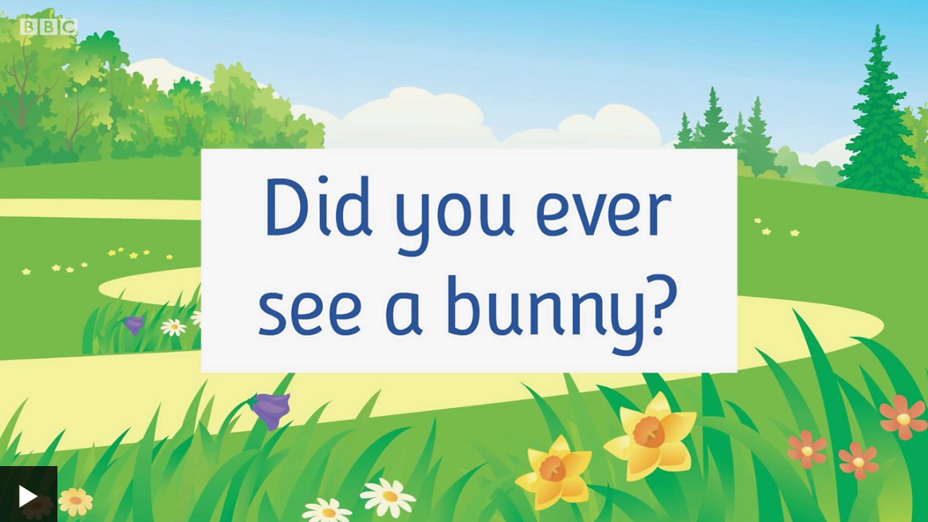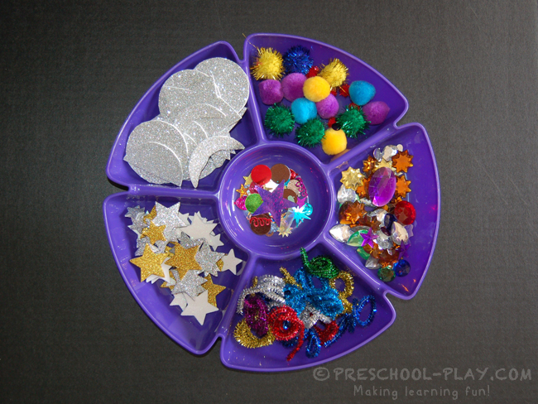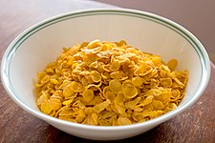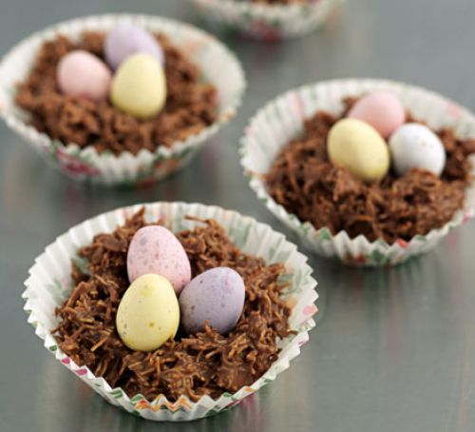

Can you use glue and collage materials to decorate a picture of an Easter Egg?

**Nursery**

**Home Learning**

**Week 2**

Can you melt chocolate and mix with cornflakes to make an Easter nest?

Use this website to learn these Nursery Rhymes: <https://www.bbc.co.uk/teach/school-radio/nursery-rhymes-a-to-z-index/z4ddgwx>

Can look at the pictures with your family?