Home Learning Timetable
This timetable may help you add structure to your child’s day. Children like routine, this may help them understand what the daily activities are going to be. This may also help you reduce the amount of time your child spends passively watching television.
Before 9am  Get up, get dressed, brush your teeth and have breakfast. Play with your toys and relax. | 9 – 9.30am  Indoor physical activity  PE with Joe live session on Youtube:  https://www.youtube.com/thebodycoachtv  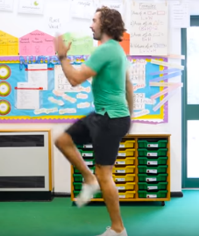 | 9.30 – 10am  Outdoor physical activity. Go on a walk, play in the garden, learn to skip. | 10 – 11am  Complete a selection of activities from the school website & read a book. (No electronics) | 11 – 11.20am  Relax and enjoy educational games on your ipad / computer or play a board game.
11.20 – 12am  Complete a selection of activities from the school website & read a book. (No electronics) | 12 – 1pm  Enjoy lunch and free time with your family. Play with your toys and relax. | 1 – 2pm  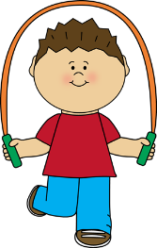  Physical activity indoor / outdoor. Go on a walk, play in the garden, learn to skip. | 2-3pm  Complete a selection of activities from the school website & read a book. (No electronics) | 3pm onwards  Enjoy free time with your family, reading stories, playing with your toys, meal and bedtime.

