3rd September 2019

Dear Parents/Carers,

Robin Wood Parent Meeting

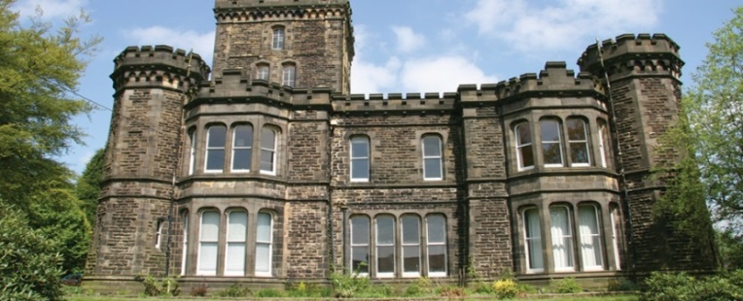
Robin Wood at Dobroyd Castle, Todmorden

We would like to invite you to meeting regarding the upcoming Year 6 Residential Trip to Robin Wood from Monday September 23rd – Wednesday September 25th 2019.

The purpose of the meeting is to ensure that you are fully informed about the trip, including the items your child will need to take as well as to ask any questions you may have.

The meeting will take place on Thursday 12th September 3:15pm in the KS2 Hall.

Please confirm your attendance by returning the slip below

Yours sincerely,

Mr P Morgan
Headteacher

--------------------------------------------------------------------------------------------------------------------------
Please return the slip to school by Friday 6th September

Child’s Name: ______________________________________________ Class _______
I will be attending the Robin Wood Parent Meeting on Thursday 12th September 2019 at 3:15pm in the KS2 Hall

Please tick this box if you require bilingual assistance
انگلش زبان سمجھنے کی دشواری کے لئے مدد درکار ہے تو یہاں پر ٹِک کریں

Language required ___________________________

