Grammar

Complete a section of your grammar book each day.

Can you become a word type expert?

What is:

1. A noun
2. A verb
3. An adverb
4. An adjective

Please do not answer in the text book, use the copy book provided.

**Reading (Everyday)**

Oxford Owl is a fantastic resource for reading and our class login is: Username: year22k Password: ABCDEF

<https://www.oxfordowl.co.uk/please-log-in?open_loginbox=true>

Choose a fiction or non-fiction text to read each day. Answer these questions about each book you read (Record them in your home learning book):

1. How was the character feeling in the story? How do you know?

2. What happened in the book? What was the main event?

3. What did you like about this book and why?

**Maths (Everyday)**

1.See the attached sheet full of arithmatic problems. Challenge yourself to complete them all. Remember to use jottings to help you.

2.Can you find any 2D or 3D shapes around your home? Once you have found them, take a picture or draw the shape. Write down the properties of these shapes and compare what you have found.

3. Help your family to prepare food in the kitchen. Measure the different ingridients and record what you have used in your book with the method underneath. Remember to think about the different units you have measured in!

A useful site for different maths games is Top Marks - <https://www.topmarks.co.uk/maths-games/hit-the-button>. Home learning -<https://whiterosemaths.com/homelearning/year-2/>.

You can also use all of the different activites on TTRS including the times tables that your teacher has set for you.

**Phonics/Spelling:**

This week’s spelling rule – The 'zh' sound spelt 's'.

Look at the spelling list you have to practice any previous spelling rules.

To support Phonics learning, please access the free games on – spelling here <https://www.phonicsbloom.com/> or <https://www.phonicsplay.co.uk/>

Lots of these games will also work on an IPad or Smart phone.

Practice the spelling words each day.

Read, cover and write each word.

Draw a picture to help you remember each word.

**6. pleasure**

**7. measure**

**8. occasion**

**9. usually**

**10. leisure**

**1. television**

**2. treasure**

**3. usual**

**4. division**

**5. vision**

**Year 2 Home Learning Tasks**

**Week 2.**

**Other curriculum areas (1 or 2 subjects per afternoon):**

Science – Carry out a material hunt in your house. How many different materials can you find? What are different objects made out of and what properties do they have?

R.E – Write a diary entry considering how it would feel as one of Jesus's disciples that he visited after his crucifixion. Christians believe that after his death he rose again and visited his disciples, write a letter or a diary entry from one of his disciples explaining how they may feel.

Geography - Draw a bird’s eye view map of your bedroom and create a key for your map.

History – Research a famous explorer who you think is significant and write a diary entry from their perspective.

Art/DT – Can you design a boat for Christopher Columbus? What materials would you use? Add labels to your drawing.

P.E – Practice your throwing and catching skills. Teach anyone at home the invasive games you learnt in school. Access Go Noodle at - <https://www.gonoodle.com/>

**The website Twinkl, has offered a free months unlimited use of their website due to the Coronavirus, this can be accessed at** [**www.twinkl.co.uk/offer**](http://www.twinkl.co.uk/offer) **and entering the code UKTWINKLHELPS -**

**Visual Timetable**

You have been set work to complete each day at home, just like at school it is helpful to have a timetable of what you are doing when. To help make sure you can fit in all your work your task is to create a visual timetable, including the amount of time that you will be spending on each of your different tasks. Don't forget to give yourself time for lunch, exercise and play!

**Writing Tasks (Everyday):**

1. Re-write one of the stories you have read but change the character and setting to make it your own.
2. Edit your story for effect.

* Have you used the correct punctuation?
* Is it interesting and does it include adjectives and adverbs?
* Does it make sense?

1. Write a poem about the weather.

-How does it make you feel?

-Include a simile.

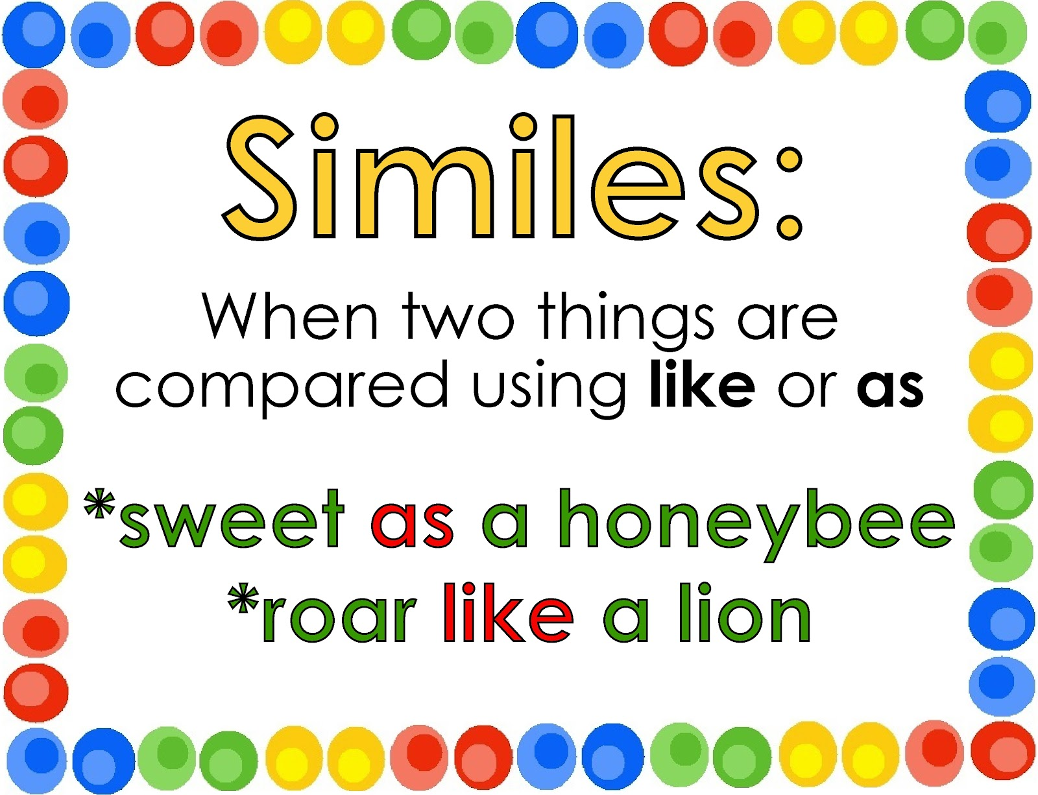

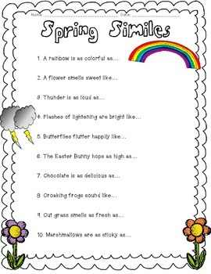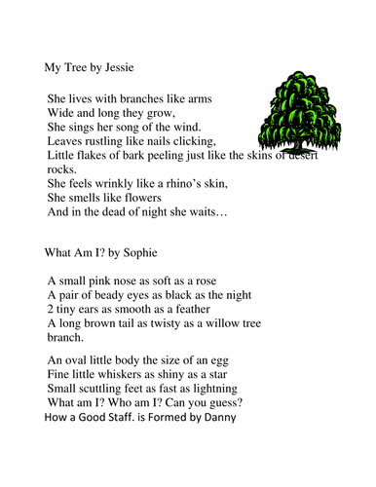

Year 2

Week 2 - Examples of Poems

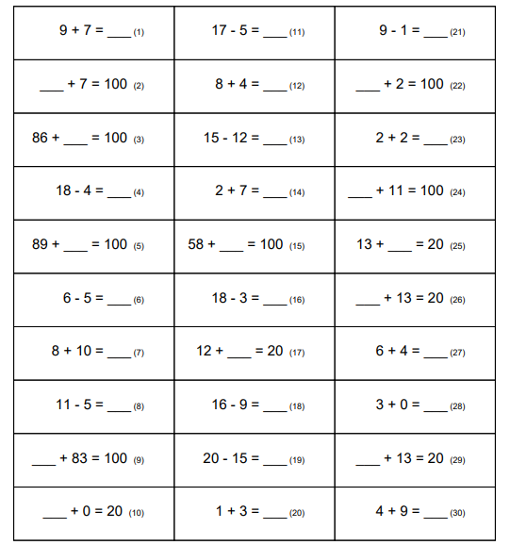Year 2

Week 2 Arithmetic Challenge

